**Project 1**

**Datasets:**

Primary Dataset – Insurance Sample Dataset

Secondary Dataset – Global Financial Development Database

**Note:**Use Data Blending with Relationships between Country Code, Country, and Year

* In the connect window select Microsoft Excel -> import Insurance and Global Financial Datasets
* Navigate Data-> Edit blended relationships and created a custom blend as mentioned in the image

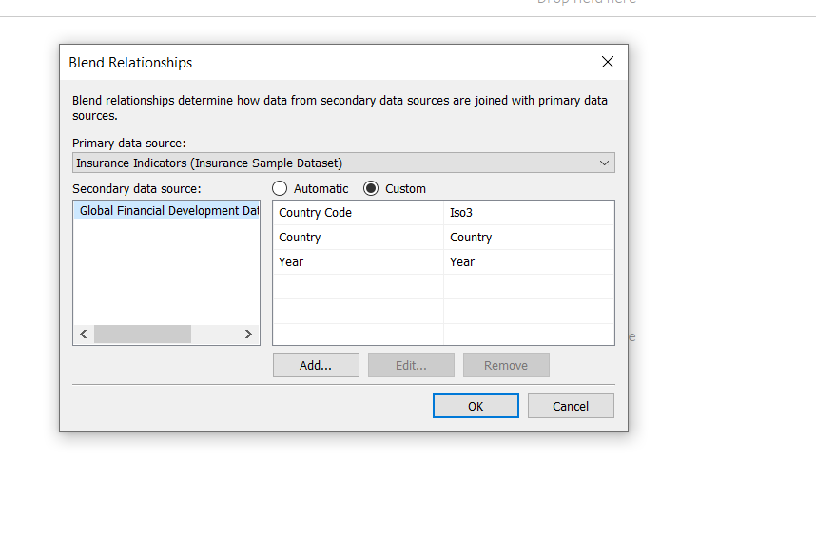

**Steps to Perform:**

1. Create a geographic map showing the countries' fields. Color the map based on the income column from the secondary dataset
   1. Include income group filter in the dashboard

* Add country from Income dataset to details, marks to map. This will create a map with all the countries in the Data set highlighted
* Add the Country code from Income Dataset to the label to see the country codes on the map

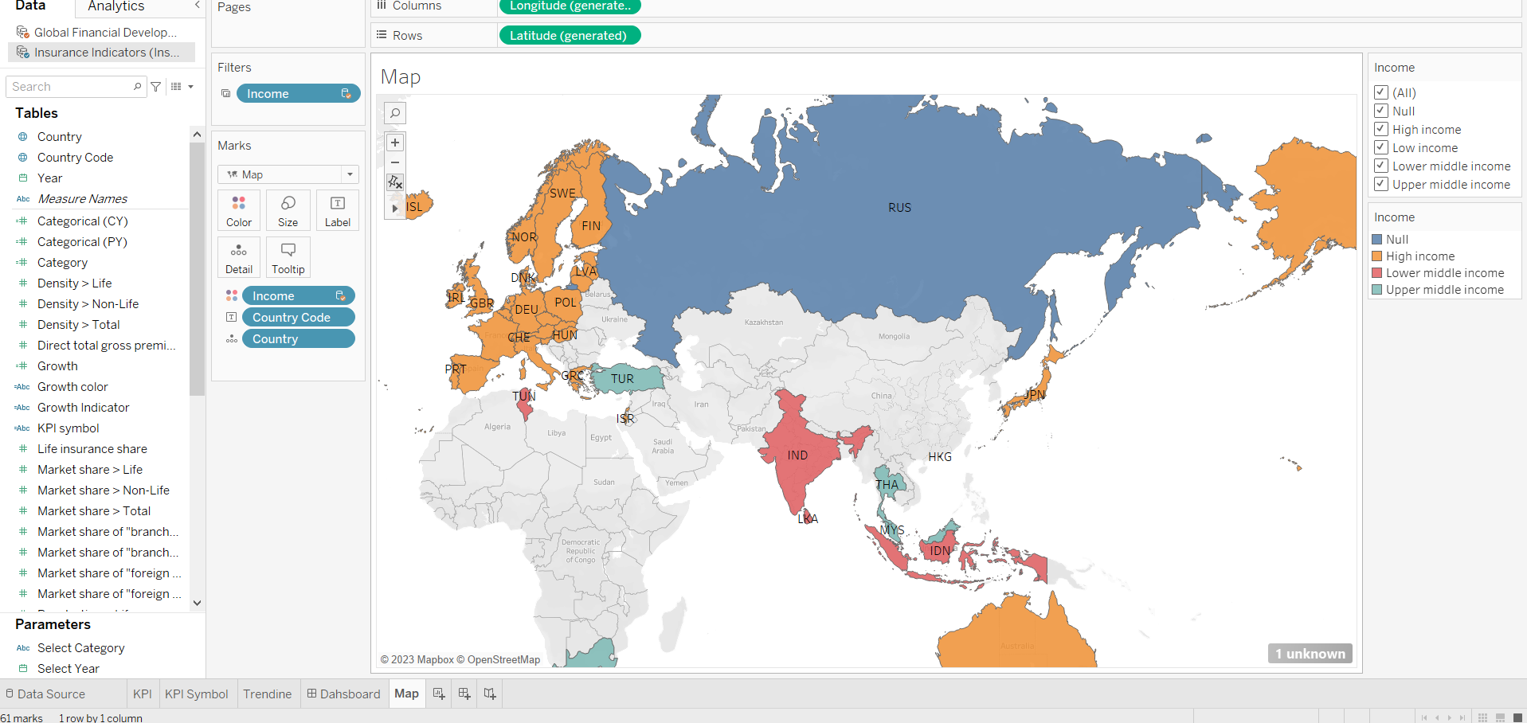

* Add Income from Global Dataset to color to see the distinction color distinction between multiple income groups
* Add income to filters (include all). Right-click on the income filter and select show filter.
* The sheet has been named Map

1. Include a webpage to show data from the world bank webpage driven by an URL action from a geography graph (<https://en.wikipedia.org/wiki/Country>)
   1. The country names on the map will act as the trigger

* Click on the new dashboard icon at the bottom of the screen
* This will create a new dashboard
* Select the map sheet, the sheet will appear on the dashboard
* Make the map sheet into a floating container

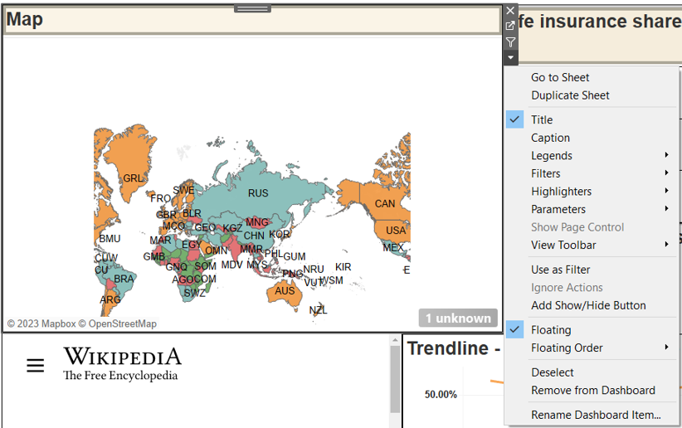

* Add a webpage from the dashboard objects
* Paste the URL in the pop-up window: <https://en.wikipedia.org/wiki/Country>)
* Add an URL action

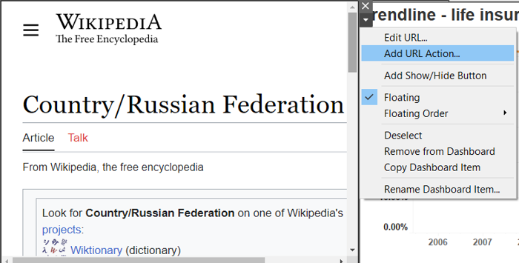

* Source sheet: Map, Run action: Select and URL: [https://en.wikipedia.org/wiki/<Country>?view=chat](https://en.wikipedia.org/wiki/%3cCountry%3e?view=chat)
* This will load the Wikipedia page of the country selected on the Map sheet on the dashboard

1. Create a KPI Table to show the comparison between the selected period and the period prior to the selected one
   1. Create two parameters for Year Selection and Category Selection
   2. Category parameter includes life insurance share, market share, penetration, ratio of reinsurance accepted, and retention ratio
   3. Create a calculated field to calculate the Growth %
   4. Create a table to show these values
   5. Title should be updated based on the category selection

* Create a new sheet and name it as KPI
* Create two parameters-Select category and year selection as mentioned in the below images

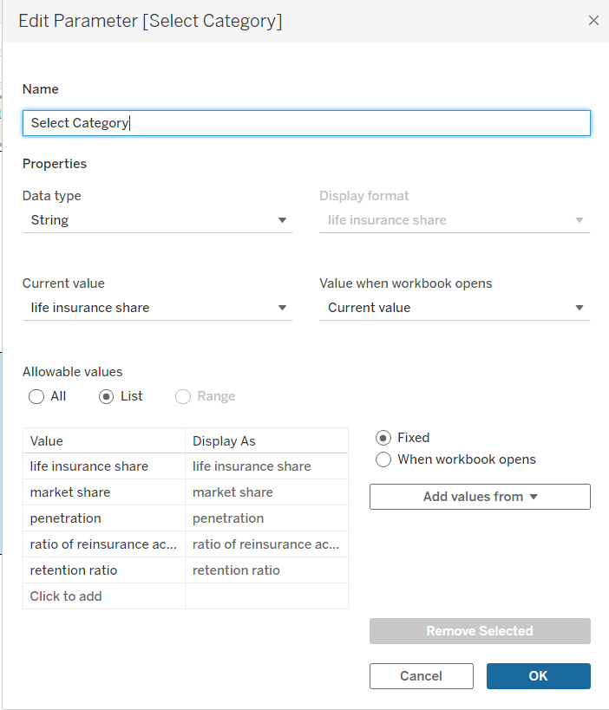

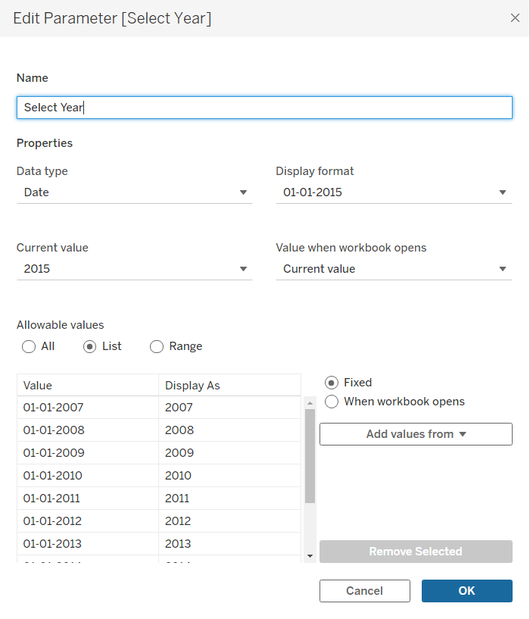

* Right click on the parameters and select show parameter
* Now create the following calculated fields
* Category
* Categorical (CY)
* Categorical (PY)
* Growth

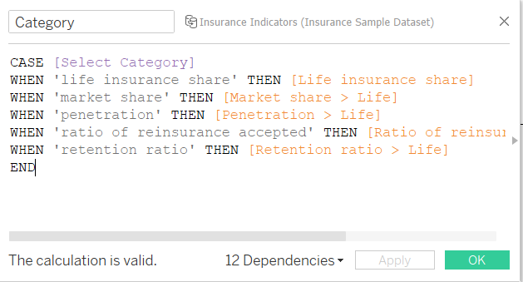

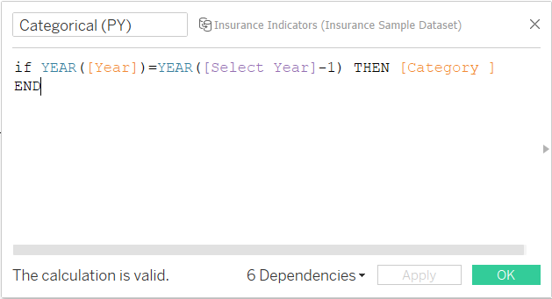

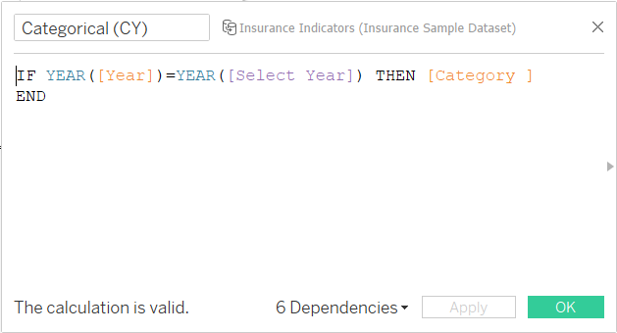

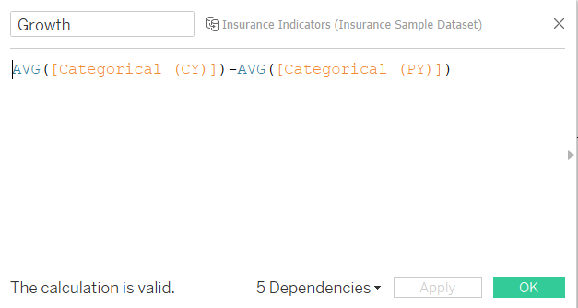

* Drag Measure Names to Row and filter it to Categorical (CY), Categorial ( PY), and Growth. Add Measure Values to Text Mark card

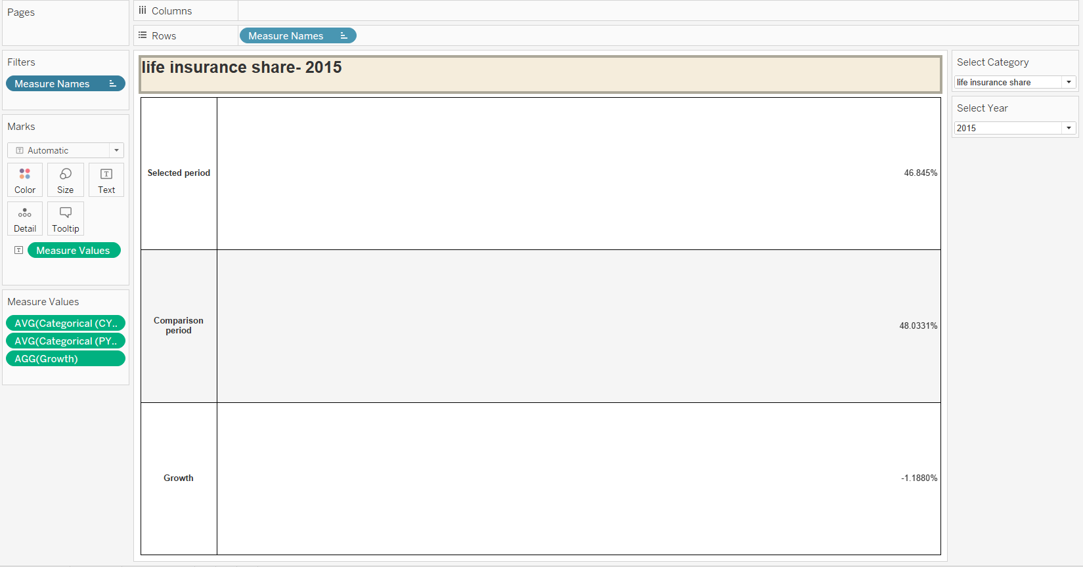

* Change the sums to Averages in the measure values for CY and PY.
* Do the necessary formatting and you will get a table as shown in the above picture
* The table values will dynamically change on the parameters selection of Select category and Year Selection
* Edit the title of the KPI sheet as shown in the below picture so that the title changes dynamically

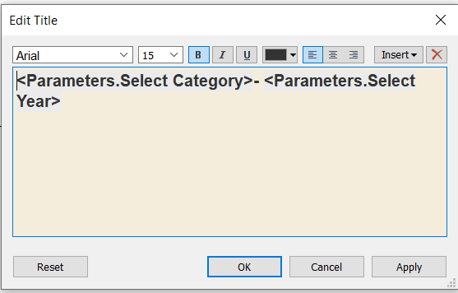

1. Create Growth Indicator Shapes based on the Growth %
   1. Growth indicator displays Negative, No Change, and Positive as values and corresponding shapes against it

* Create a new sheet KPI symbol (Ensure the parameters-Select year and Select category are shown)
* Create two more calculated fields
* Growth color
* Growth Indicator

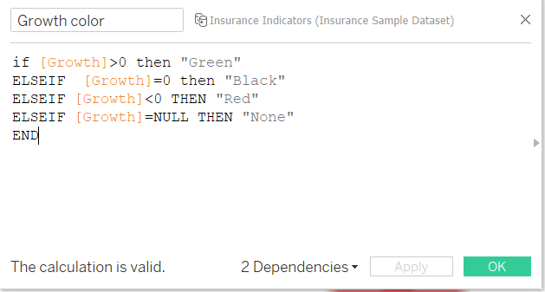

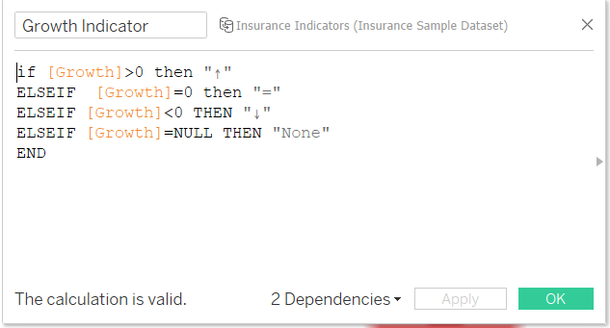

* Set Marks to Shape. Add growth color to Color and Growth Indicator to Shape

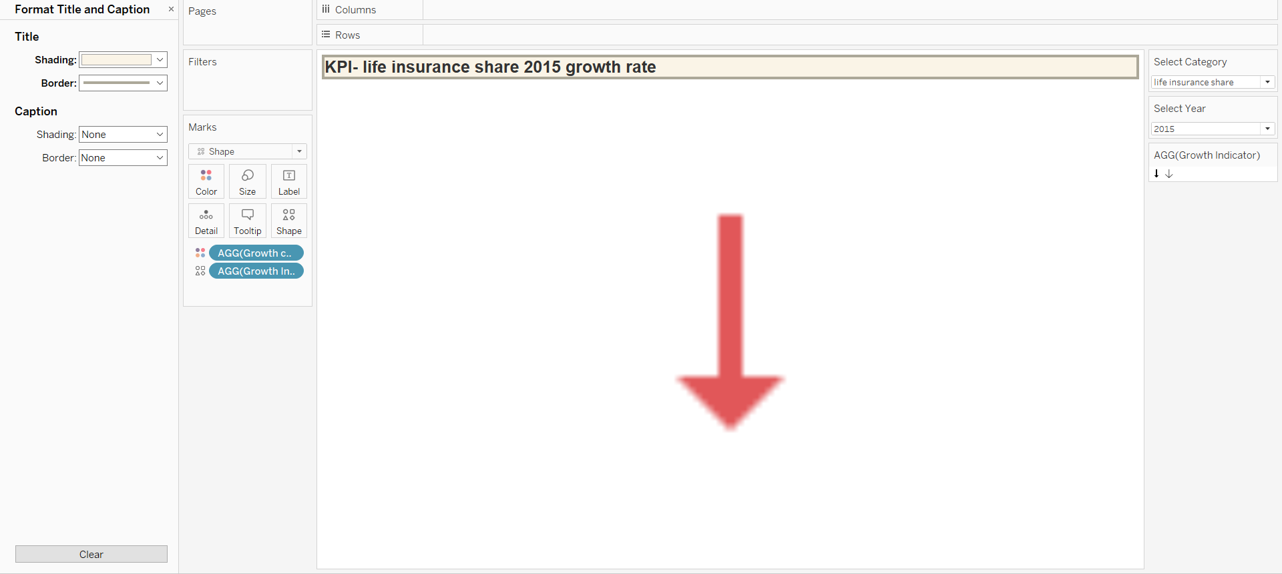

* Make necessary formatting and you will get a sheet as shown above

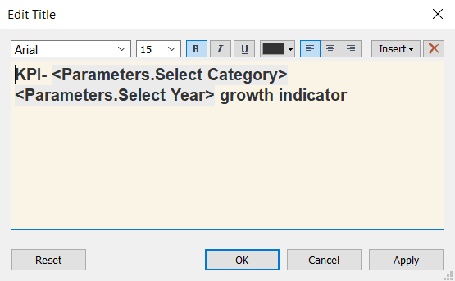

* Make the above changes to the title so that it will change dynamically based on the Parameter selection

1. Create a trend line to show the selected category values
   1. The line shows an arrow or triangle at the last mark

* Create a new sheet named Trendlines (Ensure parameters are shown)
* Add year to columns and Category to rows
* Change to aggregation to average
* Add year to pages

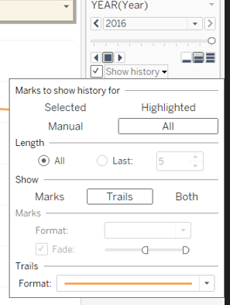

* Ensure the above settings are applied
* Change mark to shapes and select the tail shape

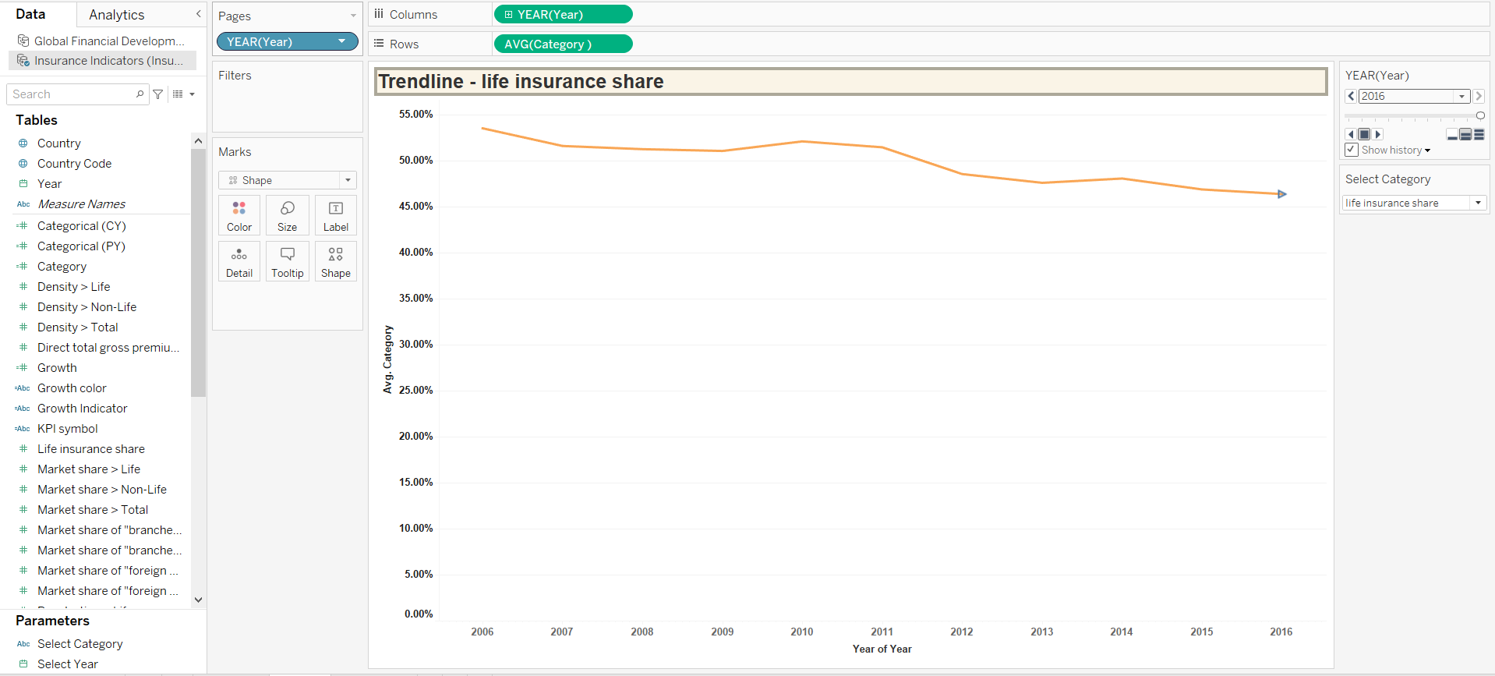

* The final sheet will look like the above sheet

I added all the sheets to the dashboard as Tiled and then made them floating and changed the formatting. The final Dashboard looked like the below image.

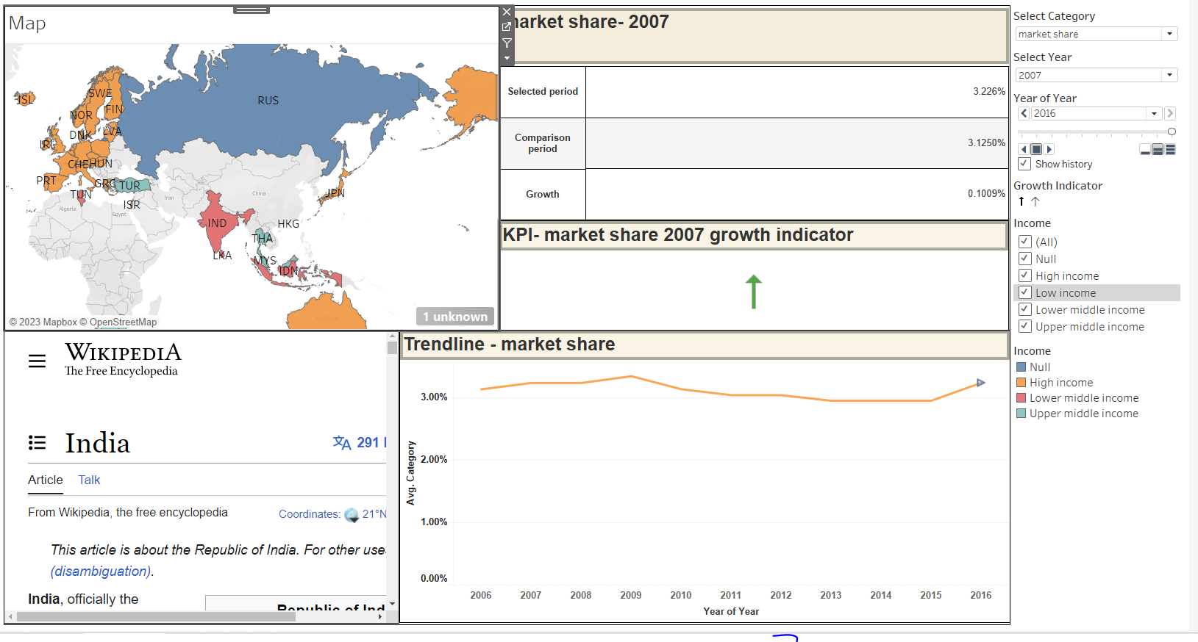

* Made Income group to act as filters for all the sheets in the dashboard

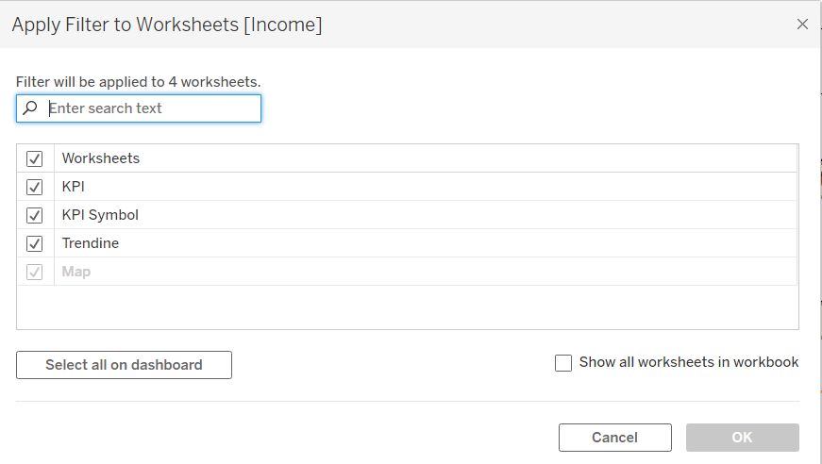

* Created a filter action Filter 1: Dashboard-> Actions-> Add-> Filter

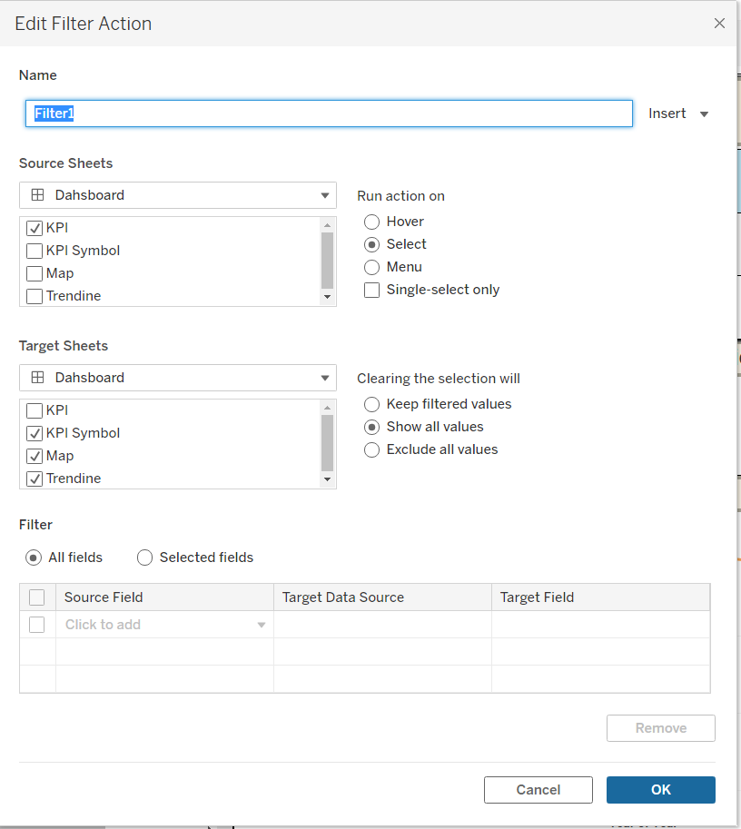

Link: https://public.tableau.com/views/Project_Final_16909320907150/Dahsboard?:language=en-US&publish=yes&:display_count=n&:origin=viz_share_link